Day in the Life of the Hudson River 10/14/21
PAPSCANEE PRESERVE, RENSSELAER COUNTY
RIVER MILE: 140
Salt Front: ~ RM 49
Robert C Parker School – Leiana Hawkins and 7 adults
34 students, 1st, 2nd, and 8th grade
Latitude 42.571899 N & Longitude – 73.75013 W

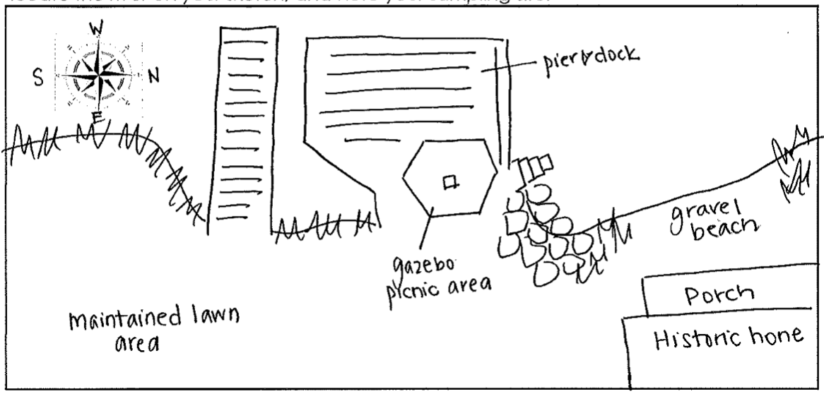
Location: Papscanee Preserve, 150 Staats Island Road, Castleton-On-Hudson, Rensselaer County, NY
Area: Private Residence- a Dutch home built in 1690s, maintained lawn, dock, and pier, small gravel beach
Surrounding Land Use: 100% Other: Single house not in primary use, surrounded by Papscanee Preserve
Sampling Site: Pier, grassy, small gravel beach
Shoreline: 50% Muddy, 50% Rocky primarily vegetation, small section of gravel beach
Water: calm, 4 feet at deepest

ITEM |  | Time | Reading |  |  |  |  |  | Comments
Physical
Air Temperature |  | 11:00 AM | 68 ºF |  |  |  | 20 ºC
Wind Speed: |  | NA
Weather today |  | 11:00 AM – No rain, mostly cloudy (51-75%)
Weather the past 3 days: |  | About 10 degrees above average temperatures
Tides- |  | Time | Rising, Falling, Unchanged |  |  |  | Height (cm)
 |  | NA
Current- |  | Time | Cm/sec |  | Knots |  | North/South |  | Ebb/Flood/Still
 |  | 10:45 AM  11:00 AM  11:15 AM  11:30 AM | 5.85  4.48  -  9.51 |  | 0.11  0.09  -  0.18 |  | North  North  Still  South |  | Flood  Flood  Still  Ebb
Water Temperature |  | 11:00 AM  11:15 AM  11:30 AM | 64 º F  64 º F  64.5º F |  |  |  | 17.9 º C  17.9 º C  18.1 º C |  | Depth of collection: 3 ft
Turbidity- Secchi Disk |  | 11:15 AM  11:30 AM  11:45 AM | 53 cm  53 cm  46.5 cm |  |  |  |  |  | Water looked yellowish clear.
Chemical
Salinity- meter |  | 11:00 AM  11:15 AM  11:30 AM | 110 ppm  110 ppm  110 ppm
DO – Meter |  | Time | Temp |  |  |  | ppm DO |  | % saturation
 |  | 11:00 AM  11:15 AM  11:30 AM | 18 º C  18 º C  18 º C |  |  |  | 9.2  9.1  9.4 |  | 98.6%  98.2%  99.5%
pH – meter |  | 11:00 AM  11:15 AM  11:30 AM | 7.75  7.86  8.15
Biological
Fish |  | Number | Name |  |  |  | Length of longest
DEC Scott Wells dropped off these fish after electroshocking |  | 1  1  2  1  1 | American Eel  White Perch  Large Mouth Bass  Channel Catfish  Blue Gill
Fish Totals |  | TOTAL: 6 | Diversity: 5
Macroinvertebrates |  | Number | Name |  |  |  | Length of longest
 |  |  | NA
Macroinvertebrate Totals |  | TOTAL: 0 | Diversity: 0
Boat Traffic
 | Time |  |  | Name |  | North/Southbound |  | Light/Loaded
Commercial | 9:40 AM |  |  | Barge |  | South |  | Loaded
Recreational | 10:20 AM  10:25 AM |  |  | Fishing Boat  Sail Boat |  | Anchored  South |  | -  -

